Questions:  
(*For each of these questions, take a screenshot of Wireshark, and attach it to your answer*).

1. Is your browser running HTTP version 1.0 or 1.1?
   1. as shown in screenshot

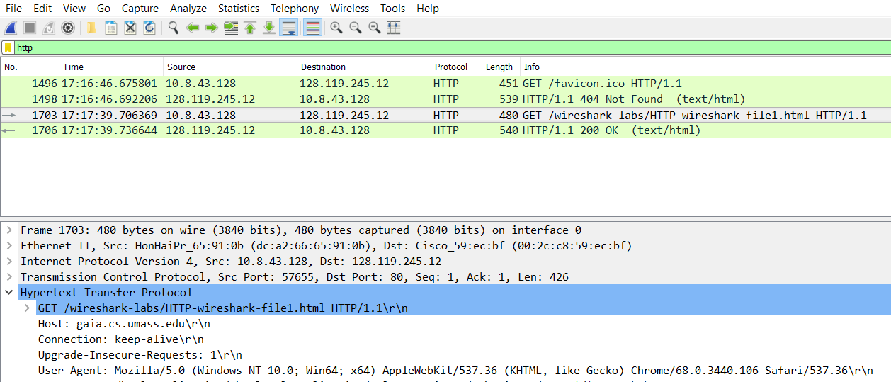

1. When was the HTML file that you are retrieving last modified at the server?

Monday September 17th 2018 at 05:59:01

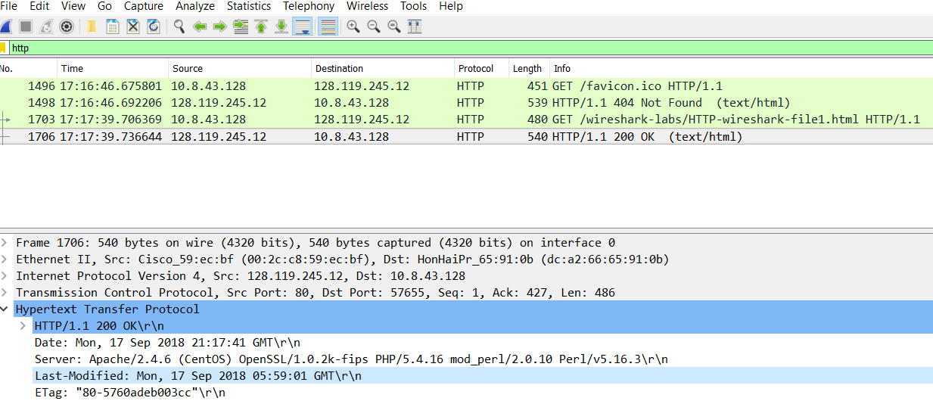

1. What is the IP address of your computer? Of the gaia.cs.umass.edu server?

10.8.43.128 and 128.119.245.12

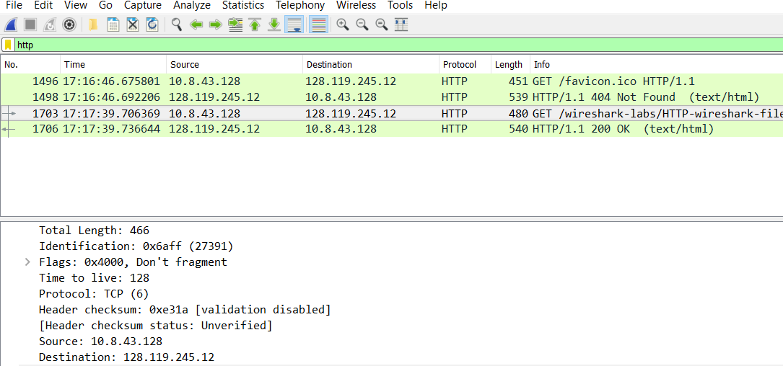

1. What languages (if any) does your browser indicate that it can accept to the server?

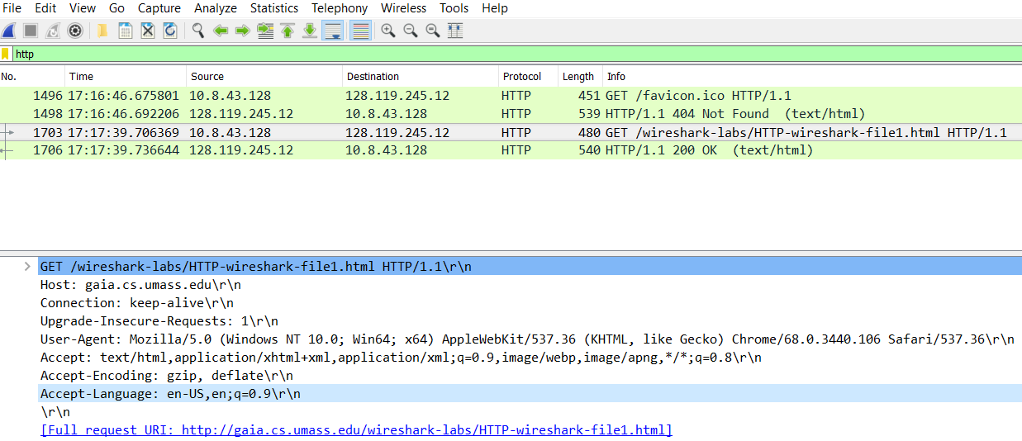

1. When was the HTML file that you are retrieving last modified at the server?

Monday September 17th 2018 at 05:59:01

